**VISVESVARAYA TECHNOLOGICAL UNIVERSITY**

**“JnanaSangama”, Belgaum -590014, Karnataka.**



**LAB REPORT**

**on**

**Artificial Intelligence (23CS5PCAIN)**

***Submitted by***

**Soham Hathi (1BM23CS335)**

***in partial fulfillment for the award of the degree of***

**BACHELOR OF ENGINEERING**

***in***

**COMPUTER SCIENCE AND ENGINEERING**



**B.M.S. COLLEGE OF ENGINEERING**

**(Autonomous Institution under VTU)**

**BENGALURU-560019**

**Aug 2025 to Dec 2025**

**B.M.S. College of Engineering,**

**Bull Temple Road, Bangalore 560019**

(Affiliated To Visvesvaraya Technological University, Belgaum)

**Department of Computer Science and Engineering**



**CERTIFICATE**

This is to certify that the Lab work entitled “Artificial Intelligence (23CS5PCAIN)” carried out by **Soham Hathi (1BM23CS335),** who is bonafide student of **B.M.S. College of Engineering.** It is in partial fulfillment for the award of **Bachelor of Engineering in Computer Science and Engineering** of the Visvesvaraya Technological University, Belgaum. The Lab report has been approved as it satisfies the academic requirements in respect of an Artificial Intelligence (23CS5PCAIN) work prescribed for the said degree.

|  |  |
| --- | --- |
| Sonika Sharma  Assistant Professor  Department of CSE, BMSCE | Dr. Kavitha Sooda  Professor & HOD  Department of CSE, BMSCE |

**Index**

|  |  |  |  |
| --- | --- | --- | --- |
| **Sl.**  **No.** | **Date** | **Experiment Title** | **Page No.** |
| 1 | 30-9-2024 | Implement Tic –Tac –Toe Game  Implement vacuum cleaner agent | 5-11 |
| 2 | 7-10-2024 | Implement 8 puzzle problems using Depth First Search (DFS)  Implement Iterative deepening search algorithm | 12-18 |
| 3 | 14-10-2024 | Implement A* search algorithm | 19-27 |
| 4 | 21-10-2024 | Implement Hill Climbing search algorithm to solve N-Queens problem | 28-31 |
| 5 | 28-10-2024 | Simulated Annealing to Solve 8-Queens problem | 32-34 |
| 6 | 11-11-2024 | Create a knowledge base using propositional logic and show that the given query entails the knowledge base or not. | 35-39 |
| 7 | 2-12-2024 | Implement unification in first order logic | 40-44 |
| 8 | 2-12-2024 | Create a knowledge base consisting of first order logic statements and prove the given query using forward reasoning. | 45-48 |
| 9 | 16-12-2024 | Create a knowledge base consisting of first order logic statements and prove the given query using Resolution | 49-55 |
| 10 | 16-12-2024 | Implement Alpha-Beta Pruning. | 56-60 |

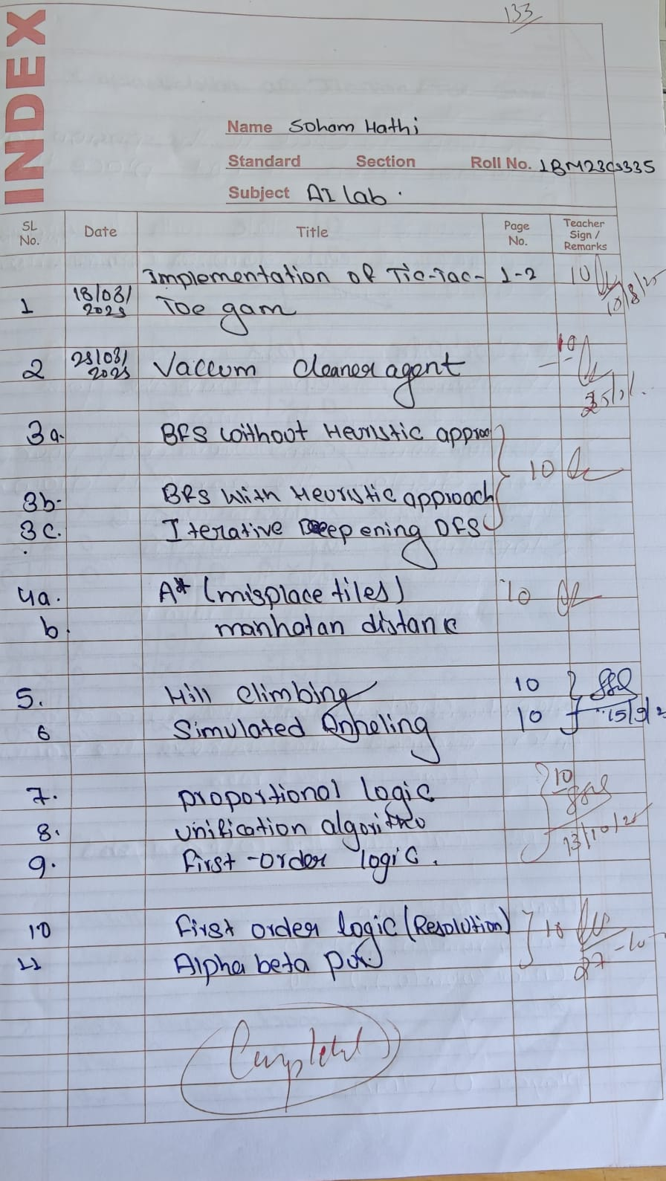

Github Link: <https://github.com/sohamhathi/sohamHathi-1BM23CS335-AI.git>

**Program 1**

Implement Tic –Tac –Toe Game

Implement vacuum cleaner agent

Algorithm:

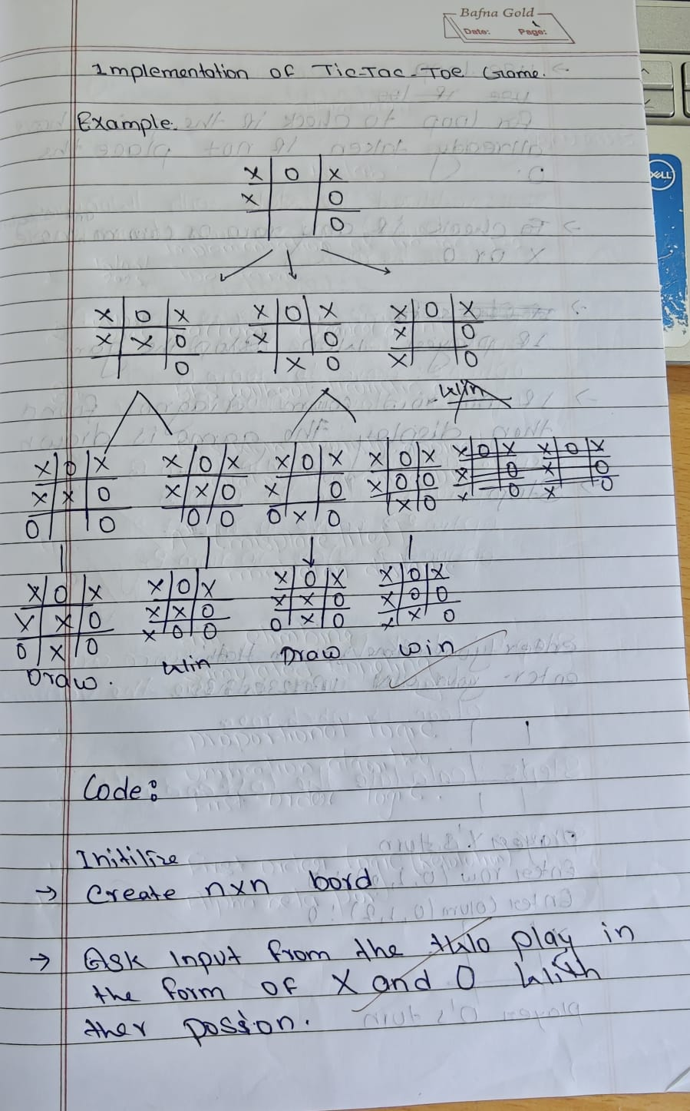

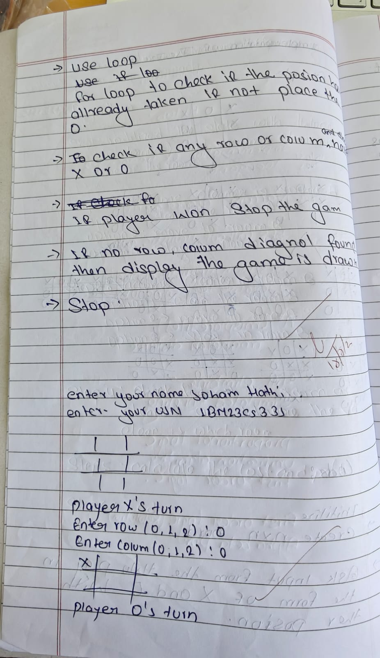

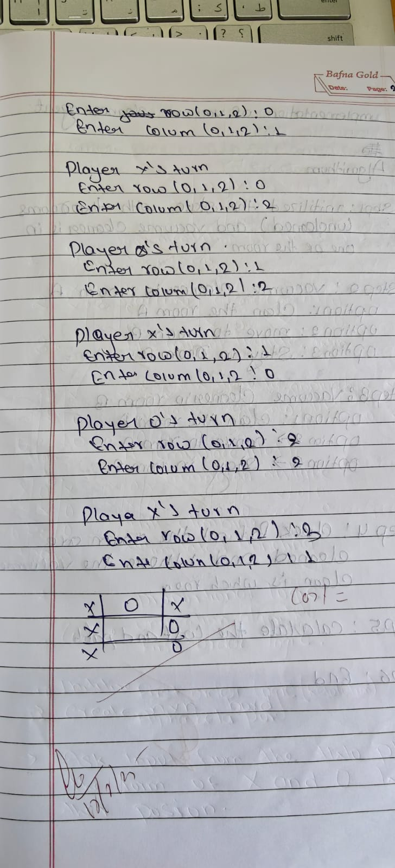

**Code:**

# tic tac toe game lab 1

name = input("enter your name ");

usn=input ("enter your usn");

def print_board(board):

for row in board:

print(" | ".join(row))

print("-" * 5)

def check_winner(board, player):

for i in range(3):

if all(board[i][j] == player for j in range(3)):

return True

if all(board[j][i] == player for j in range(3)):

return True

if all(board[i][i] == player for i in range(3)):

return True

if all(board[i][2 - i] == player for i in range(3)):

return True

return False

def is_full(board):

return all(board[i][j] != " " for i in range(3) for j in range(3))

def tic_tac_toe():

board = [[" " for _ in range(3)] for _ in range(3)]

current_player = "X"

path_cost = 0

while True:

print_board(board)

print(f"Player {current_player}'s turn.")

# Input move

row = int(input("Enter row (0-2): "))

col = int(input("Enter col (0-2): "))

if board[row][col] == " ":

board[row][col] = current_player

path_cost += 1

else:

print("Invalid move! Try again.")

continue

if check_winner(board, current_player):

print_board(board)

print(f"Player {current_player} wins!")

print(f"Path cost: {path_cost}")

break

if is_full(board):

print_board(board)

print("It's a draw!")

print(f"Path cost: {path_cost}")

break

current_player = "O" if current_player == "X" else "X"

tic_tac_toe()

**Implement vacuum cleaner agent**

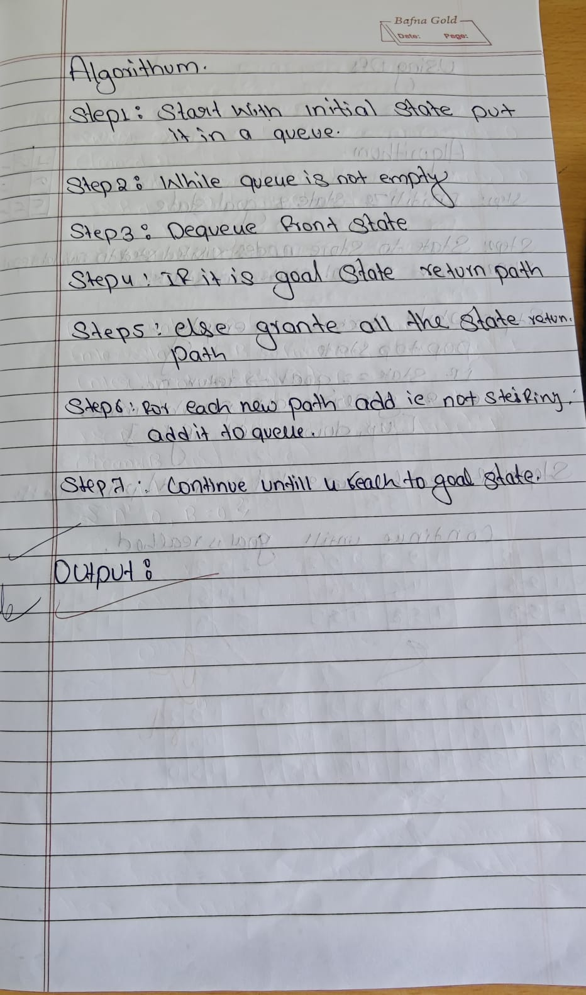

def vacuum_cleaner_4_rooms_grid():

try:

state_A = int(input("Enter state of A (0 for clean, 1 for dirty): "))

state_B = int(input("Enter state of B (0 for clean, 1 for dirty): "))

state_C = int(input("Enter state of C (0 for clean, 1 for dirty): "))

state_D = int(input("Enter state of D (0 for clean, 1 for dirty): "))

location = input("Enter location (A, B, C, D): ").upper()

if (state_A not in (0, 1) or state_B not in (0, 1) or

state_C not in (0, 1) or state_D not in (0, 1) or

location not in ('A', 'B', 'C', 'D')):

raise ValueError("Invalid input! Enter 0 or 1 for states, and location as A/B/C/D.")

except ValueError as e:

print("Error:", e)

return

environment = {'A': state_A, 'B': state_B, 'C': state_C, 'D': state_D}

cost = 0

moves = {

'A': {'RIGHT': 'B', 'DOWN': 'C'},

'B': {'LEFT': 'A', 'DOWN': 'D'},

'C': {'UP': 'A', 'RIGHT': 'D'},

'D': {'UP': 'B', 'LEFT': 'C'}

}

while True:

print("\nCurrent Environment:", environment)

print("Vacuum is at Room", location)

if environment[location] == 1:

print(f"{location} is dirty. Cleaning...")

environment[location] = 0

cost += 1

print(f"{location} is now clean.")

else:

print(f"{location} is already clean.")

if all(state == 0 for state in environment.values()):

print("\nAll rooms are clean. Turning vacuum off.")

break

move = input("Enter action (LEFT / RIGHT / UP / DOWN / STAY / EXIT): ").upper()

if move in moves[location]:

new_location = moves[location][move]

print(f"Moving vacuum {move} to {new_location}.")

location = new_location

cost += 1

elif move == "STAY":

print("Staying in the same room. (No cost)")

elif move == "EXIT":

print("Exiting manually.")

break

else:

print("Invalid move from this room! Try again.")

print("\nFinal Environment:", environment)

print("Total Cost:", cost)

vacuum_cleaner_4_rooms_grid()

**PROGRAM-2**

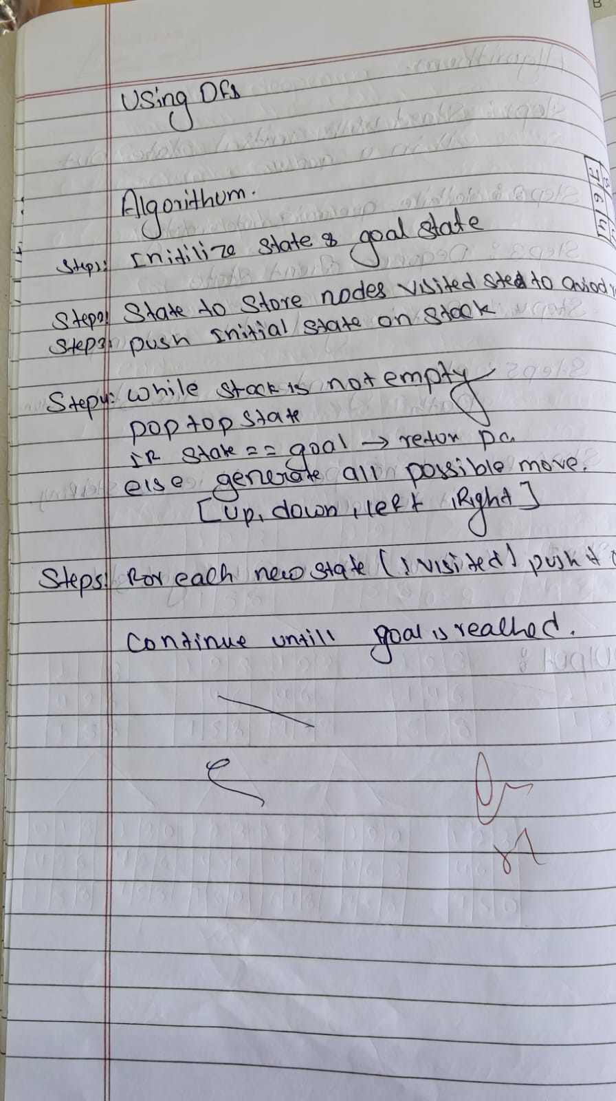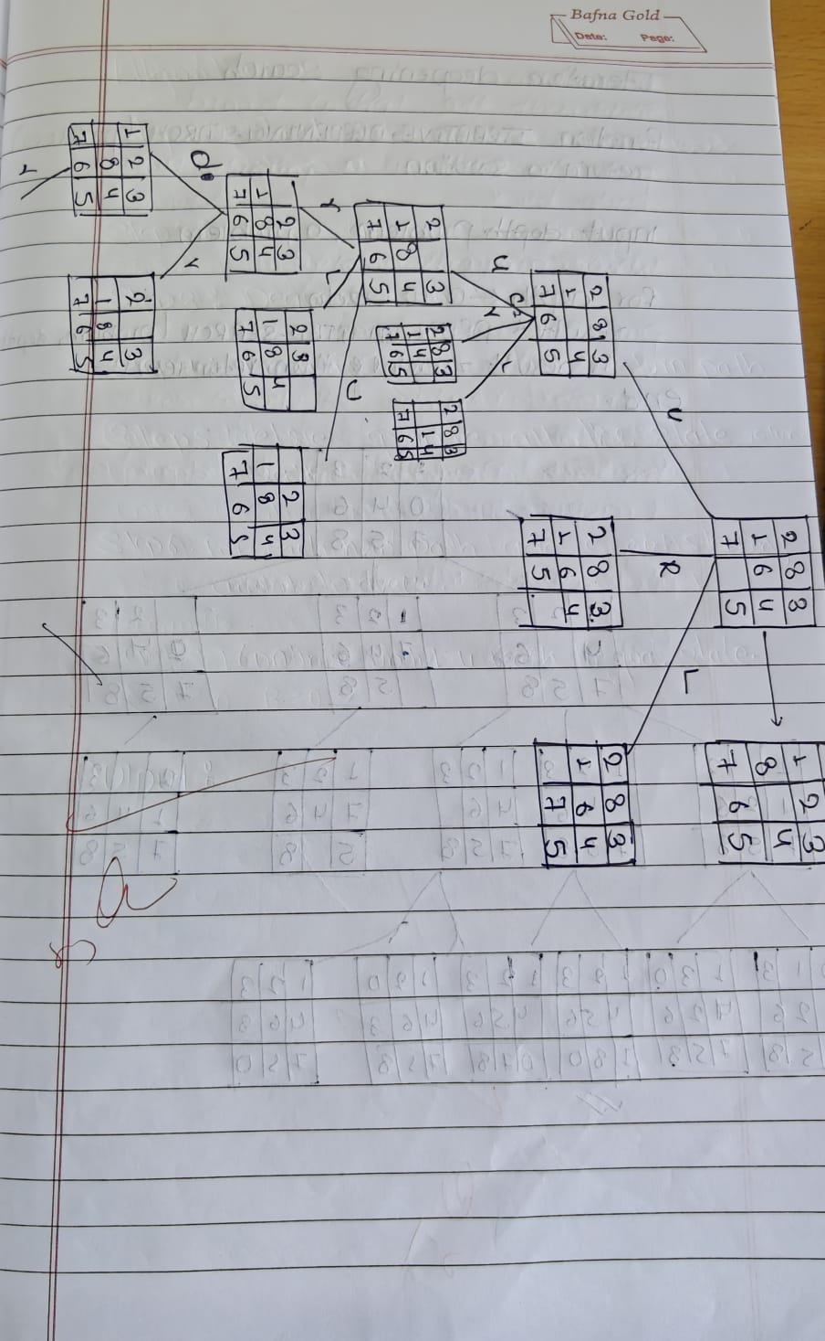

print("Soham Hathi")

print("1BM23CS335")

from copy import deepcopy

GOAL_STATE = [[1, 2, 3],

[8, 0, 4],

[7, 6, 5]]

DIRECTIONS = [(-1, 0), (1, 0), (0, -1), (0, 1)]

def is_valid(x, y):

return 0 <= x < 3 and 0 <= y < 3

def serialize(state):

return str(state)

def find_zero(state):

for i in range(3):

for j in range(3):

if state[i][j] == 0:

return i, j

def get_neighbors(state):

neighbors = []

x, y = find_zero(state)

for dx, dy in DIRECTIONS:

nx, ny = x + dx, y + dy

if is_valid(nx, ny):

new_state = deepcopy(state)

new_state[x][y], new_state[nx][ny] = new_state[nx][ny], new_state[x][y]

neighbors.append(new_state)

return neighbors

def dfs(start_state, max_depth=30):

visited = set()

path = []

solution_path = []

found = False

def dfs_recursive(state, depth):

nonlocal found, solution_path

if depth > max_depth or found:

return

serial = serialize(state)

if serial in visited:

return

visited.add(serial)

path.append(state)

if state == GOAL_STATE:

solution_path = path.copy()

found = True

return

for neighbor in get_neighbors(state):

dfs_recursive(neighbor, depth + 1)

path.pop()

visited.remove(serial)

dfs_recursive(start_state, 0)

if found:

return solution_path, len(solution_path) - 1

else:

return None, -1

if __name__ == "__main__":

start = [[2, 8, 3],

[1, 6, 4],

[7, 0, 5]]

path, cost = dfs(start, max_depth=50)

if path:

print(f"DFS found a path with cost = {cost}:")

for step in path:

for row in step:

print(row)

print("------")

else:

print("No solution found within depth limit.") 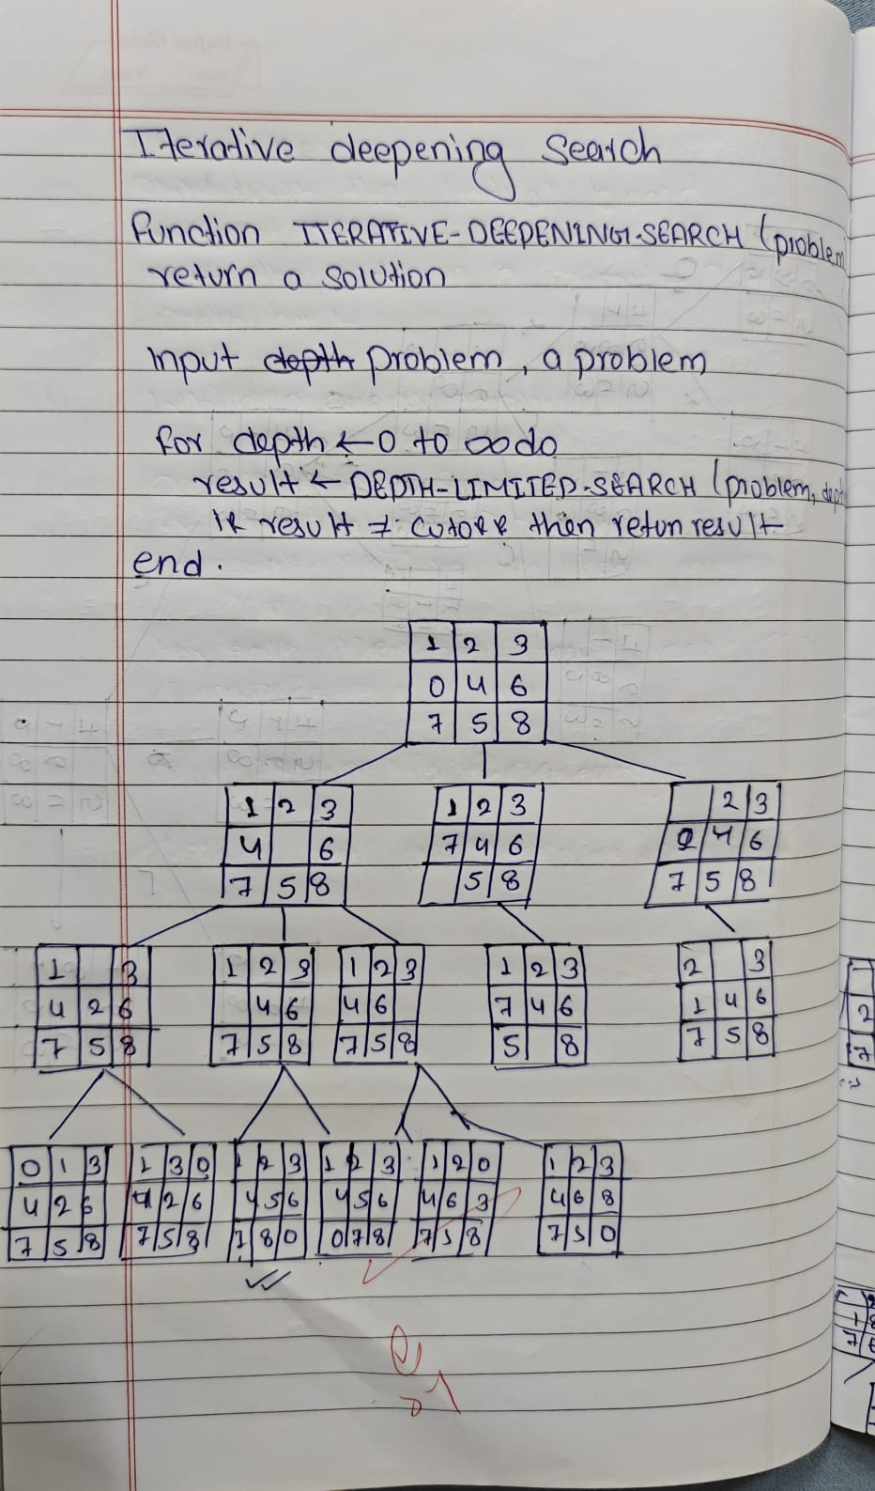

**ITERATIVE DFS**

from copy import deepcopy

print("soham Hathi")

print("1BM23CS335")

# Goal state

GOAL_STATE = [[1, 2, 3],

[8, 0, 4],

[7, 6, 5]]

DIRECTIONS = {'UP': (-1, 0), 'DOWN': (1, 0), 'LEFT': (0, -1), 'RIGHT': (0, 1)}

def find_blank(state):

for i in range(3):

for j in range(3):

if state[i][j] == 0:

return i, j

return None

def is_goal(state):

return state == GOAL_STATE

def get_successors(state):

successors = []

x, y = find_blank(state)

for move, (dx, dy) in DIRECTIONS.items():

new_x, new_y = x + dx, y + dy

if 0 <= new_x < 3 and 0 <= new_y < 3:

new_state = deepcopy(state)

new_state[x][y], new_state[new_x][new_y] = new_state[new_x][new_y], new_state[x][y]

successors.append((new_state, move))

return successors

def depth_limited_search(state, depth, path, visited):

if is_goal(state):

return path

if depth == 0:

return None

visited.append(state)

for successor, move in get_successors(state):

if successor not in visited:

result = depth_limited_search(successor, depth - 1, path + [move], visited)

if result is not None:

return result

visited.pop()

return None

# Iterative Deepening DFS

def iterative_deepening_search(start_state, max_depth=50):

for depth in range(max_depth):

print(f"Trying depth limit: {depth}")

visited = []

result = depth_limited_search(start_state, depth, [], visited)

if result is not None:

return result

return None

if __name__ == "__main__":

initial_state = [[2, 8, 3],

[1 ,6, 4],

[7, 0, 5]]

solution = iterative_deepening_search(initial_state)

if solution:

print("\nSolution found!")

print("Moves to solve:", solution)

print("Number of moves:", len(solution))

else:

print("No solution found within depth limit.")

**PROGRAM-3**

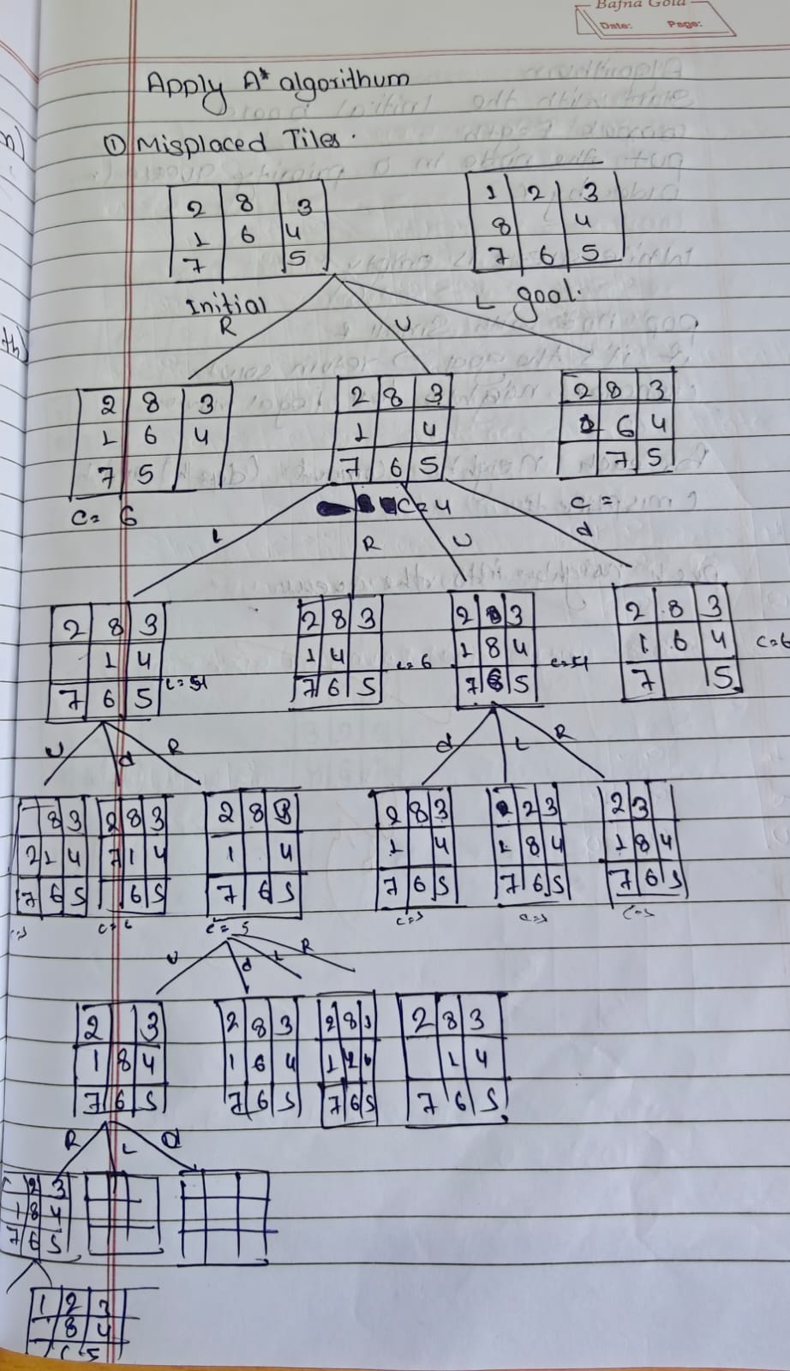

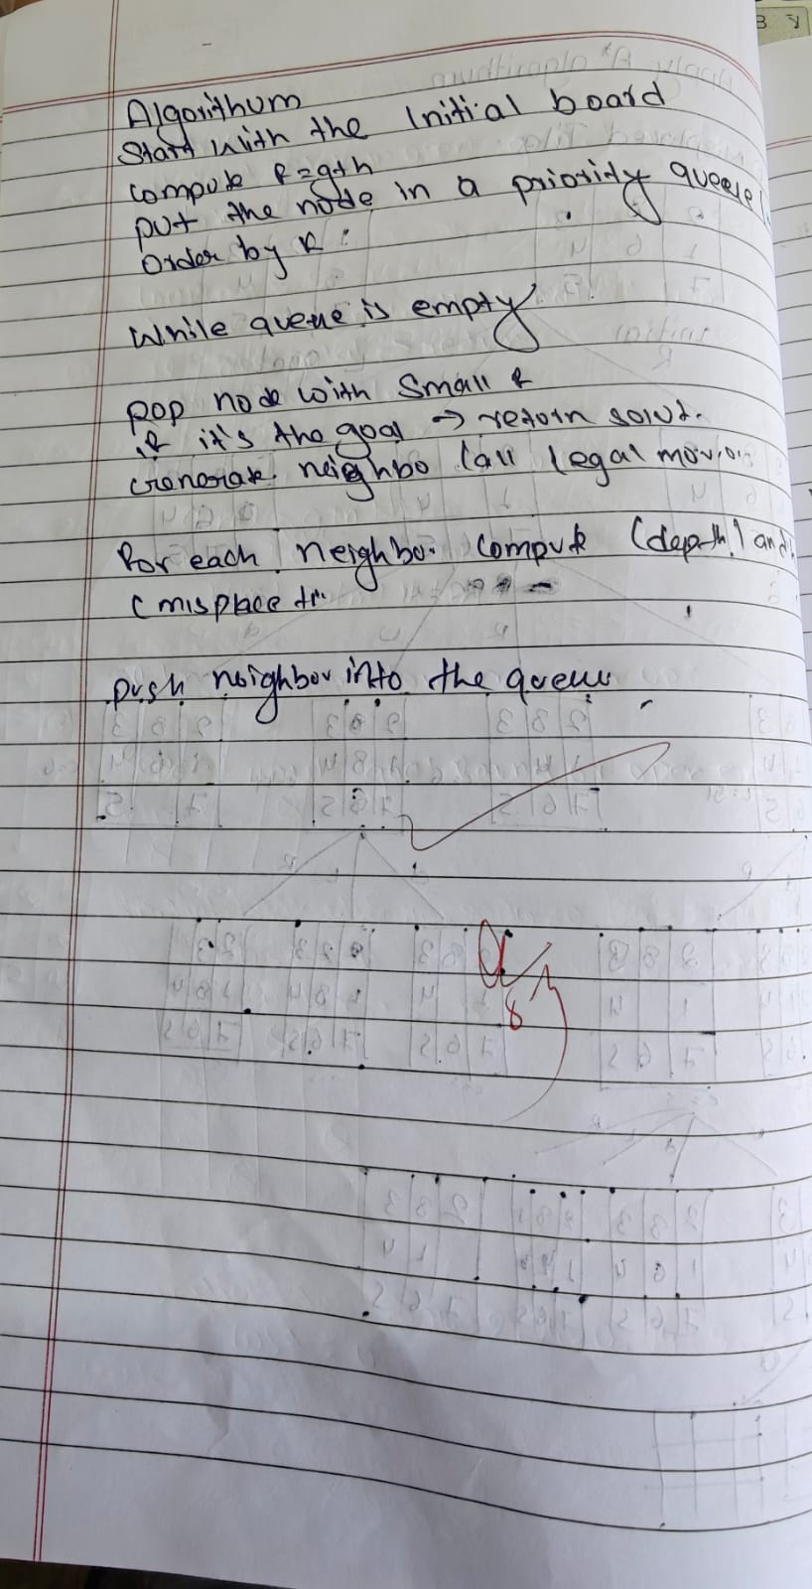

import heapq

print("soham Hathi")

print("1BM23CS335")

def manhattan_distance(state, goal):

"""Calculate total Manhattan distance of all tiles from their goal positions."""

goal_positions = {}

for i in range(3):

for j in range(3):

goal_positions[goal[i][j]] = (i, j)

dist = 0

for i in range(3):

for j in range(3):

tile = state[i][j]

if tile != 0:

goal_i, goal_j = goal_positions[tile]

dist += abs(i - goal_i) + abs(j - goal_j)

return dist

def get_neighbors(state):

neighbors = []

for i in range(3):

for j in range(3):

if state[i][j] == 0:

x, y = i, j

directions = [(-1,0),(1,0),(0,-1),(0,1)]

for dx, dy in directions:

nx, ny = x + dx, y + dy

if 0 <= nx < 3 and 0 <= ny < 3:

new_state = [list(row) for row in state]

new_state[x][y], new_state[nx][ny] = new_state[nx][ny], new_state[x][y]

neighbors.append(tuple(tuple(row) for row in new_state))

return neighbors

def print_state(state):

for row in state:

print(' '.join(str(x) if x != 0 else ' ' for x in row))

print()

def get_user_state(prompt):

print(prompt)

print("Enter 9 numbers separated by space, use 0 for blank tile (e.g. '2 8 3 1 6 4 7 0 5'):")

while True:

try:

entries = list(map(int, input().strip().split()))

if len(entries) != 9 or set(entries) != set(range(9)):

raise ValueError

break

except ValueError:

print("Invalid input! Enter exactly 9 unique digits from 0 to 8 separated by spaces.")

return tuple(tuple(entries[i*3:(i+1)*3]) for i in range(3))

def a_star_verbose(start_state, goal_state):

open_set = []

start_h = manhattan_distance(start_state, goal_state)

heapq.heappush(open_set, (start_h, 0, start_state, [])) # (f, g, state, path)

closed_set = set()

step_counter = 0

while open_set:

f, g, current, path = heapq.heappop(open_set)

step_counter += 1

print(f"Step {step_counter}:")

print(f"Current state with f = g + h = {g} + {f - g} = {f}")

print_state(current)

if current == goal_state:

print("Goal reached!")

return path + [current]

if current in closed_set:

print("This state has already been visited. Skipping.\n")

continue

closed_set.add(current)

neighbors = get_neighbors(current)

print(f"Expanding neighbors ({len(neighbors)}):")

for n in neighbors:

if n not in closed_set:

h = manhattan_distance(n, goal_state)

new_g = g + 1

new_f = new_g + h

print(f"Neighbor state with g={new_g}, h={h}, f={new_f}:")

print_state(n)

heapq.heappush(open_set, (new_f, new_g, n, path + [current]))

else:

print("Neighbor already visited, skipping.")

print("-----\n")

return None

if __name__ == "__main__":

start = get_user_state("Enter the START state:")

goal = get_user_state("Enter the GOAL state:")

print("\nStarting A* search with Manhattan distance heuristic...\n")

solution = a_star_verbose(start, goal)

if solution:

print(f"\nSolution found in {len(solution)-1} moves:\n")

for step_num, step in enumerate(solution):

print(f"Step {step_num}:")

print_state(step)

else:

print("No solution found.")

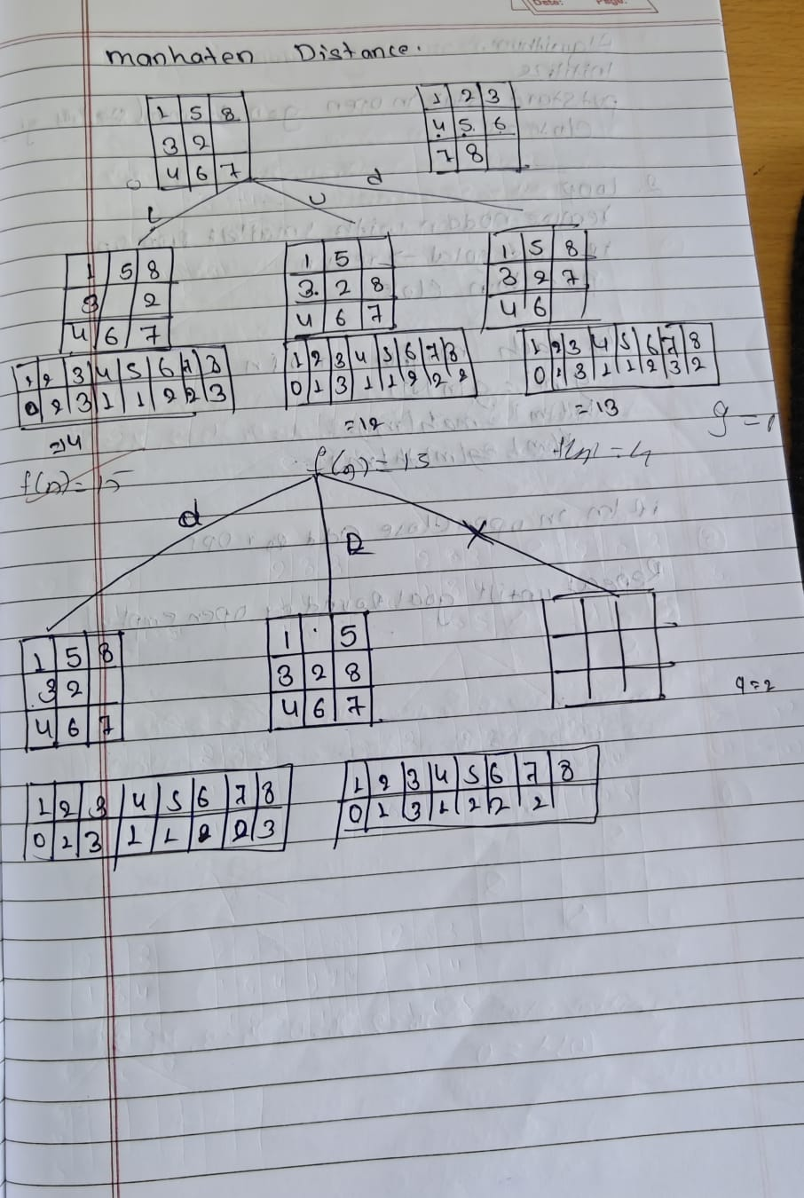

**MANHATTAN DISTANCE**

import heapq

print("soham Hathi")

print("1BM23CS335")

def manhattan_distance(state, goal):

"""Calculate total Manhattan distance of all tiles from their goal positions."""

goal_positions = {}

for i in range(3):

for j in range(3):

goal_positions[goal[i][j]] = (i, j)

dist = 0

for i in range(3):

for j in range(3):

tile = state[i][j]

if tile != 0:

goal_i, goal_j = goal_positions[tile]

dist += abs(i - goal_i) + abs(j - goal_j)

return dist

def get_neighbors(state):

neighbors = []

for i in range(3):

for j in range(3):

if state[i][j] == 0:

x, y = i, j

directions = [(-1,0),(1,0),(0,-1),(0,1)]

for dx, dy in directions:

nx, ny = x + dx, y + dy

if 0 <= nx < 3 and 0 <= ny < 3:

new_state = [list(row) for row in state]

new_state[x][y], new_state[nx][ny] = new_state[nx][ny], new_state[x][y]

neighbors.append(tuple(tuple(row) for row in new_state))

return neighbors

def print_state(state):

for row in state:

print(' '.join(str(x) if x != 0 else ' ' for x in row))

print()

def get_user_state(prompt):

print(prompt)

print("Enter 9 numbers separated by space, use 0 for blank tile (e.g. '2 8 3 1 6 4 7 0 5'):")

while True:

try:

entries = list(map(int, input().strip().split()))

if len(entries) != 9 or set(entries) != set(range(9)):

raise ValueError

break

except ValueError:

print("Invalid input! Enter exactly 9 unique digits from 0 to 8 separated by spaces.")

return tuple(tuple(entries[i*3:(i+1)*3]) for i in range(3))

def a_star_verbose(start_state, goal_state):

open_set = []

start_h = manhattan_distance(start_state, goal_state)

heapq.heappush(open_set, (start_h, 0, start_state, [])) # (f, g, state, path)

closed_set = set()

step_counter = 0

while open_set:

f, g, current, path = heapq.heappop(open_set)

step_counter += 1

print(f"Step {step_counter}:")

print(f"Current state with f = g + h = {g} + {f - g} = {f}")

print_state(current)

if current == goal_state:

print("Goal reached!")

return path + [current]

if current in closed_set:

print("This state has already been visited. Skipping.\n")

continue

closed_set.add(current)

neighbors = get_neighbors(current)

print(f"Expanding neighbors ({len(neighbors)}):")

for n in neighbors:

if n not in closed_set:

h = manhattan_distance(n, goal_state)

new_g = g + 1

new_f = new_g + h

print(f"Neighbor state with g={new_g}, h={h}, f={new_f}:")

print_state(n)

heapq.heappush(open_set, (new_f, new_g, n, path + [current]))

else:

print("Neighbor already visited, skipping.")

print("-----\n")

return None

if __name__ == "__main__":

start = get_user_state("Enter the START state:")

goal = get_user_state("Enter the GOAL state:")

print("\nStarting A* search with Manhattan distance heuristic...\n")

solution = a_star_verbose(start, goal)

if solution:

print(f"\nSolution found in {len(solution)-1} moves:\n")

for step_num, step in enumerate(solution):

print(f"Step {step_num}:")

print_state(step)

else:

print("No solution found.")

**PROGRAM-4**

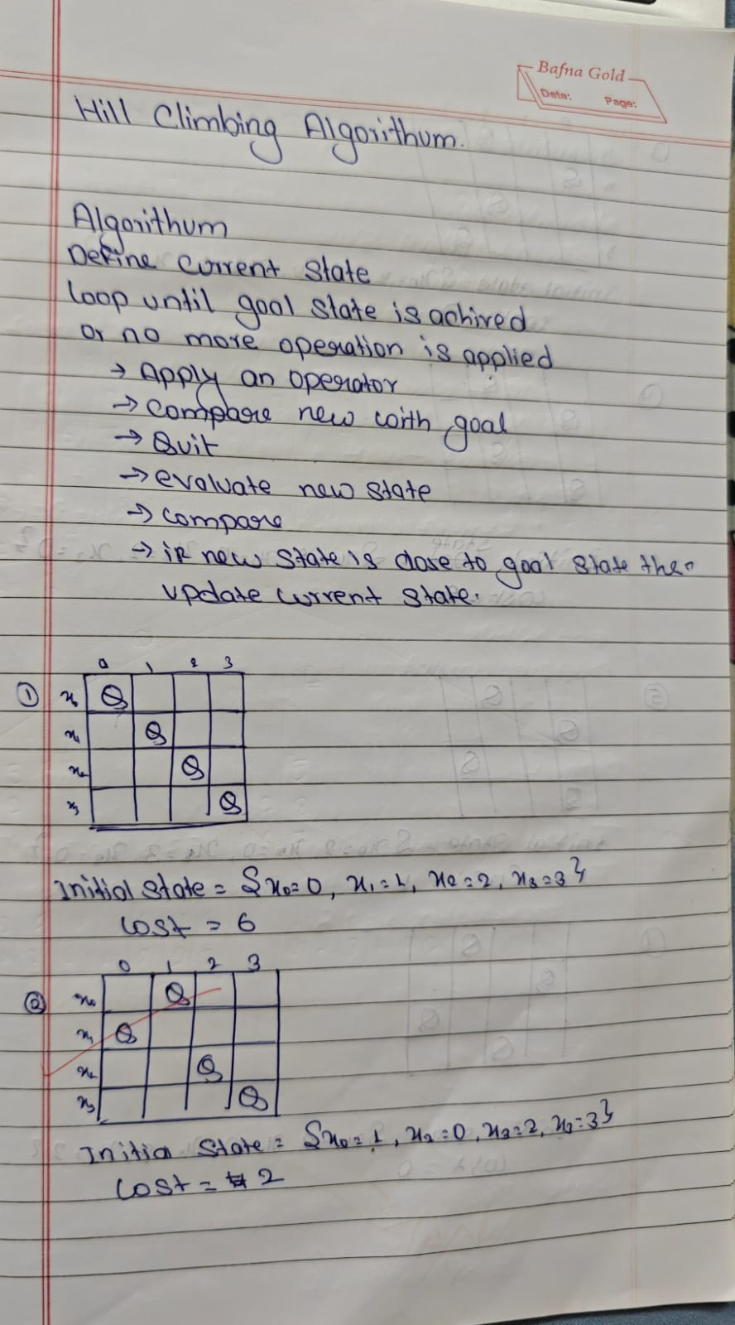

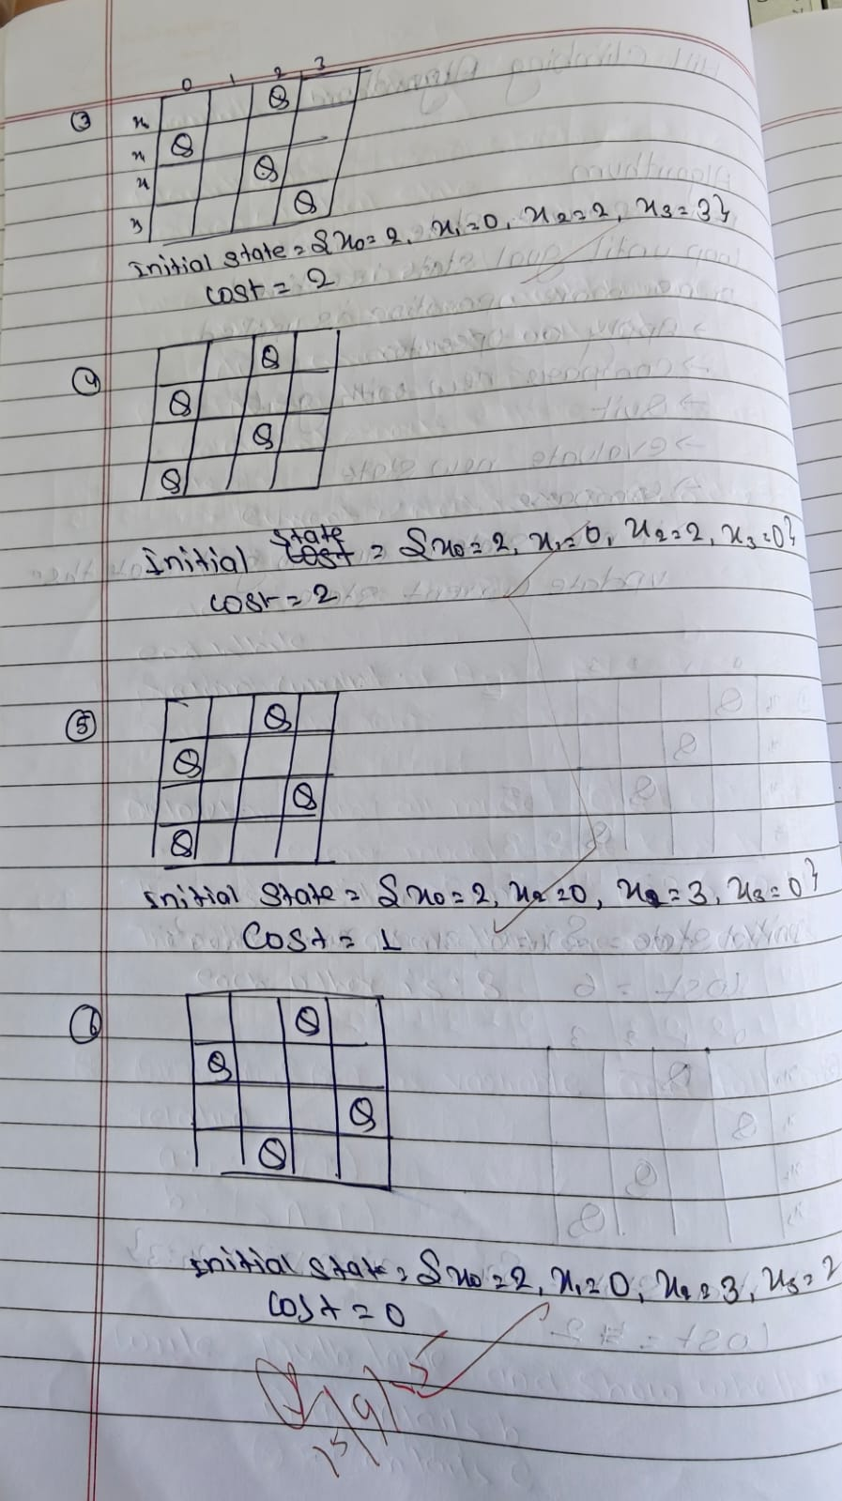

import random

import copy

print("soham Hathi")

print("1BM23CS335")

N = 4

def print_board(state):

for row in range(N):

line = ""

for col in range(N):

if state[col] == row:

line += " Q "

else:

line += " . "

print(line)

print()

def heuristic(state):

"""Calculate the number of pairs of queens attacking each other."""

h = 0

for i in range(N):

for j in range(i + 1, N):

if state[i] == state[j] or abs(state[i] - state[j]) == abs(i - j):

h += 1

return h

def get_neighbors(state):

"""Generate all neighboring states (each queen moved to another row in its column)."""

neighbors = []

for col in range(N):

for row in range(N):

if state[col] != row:

neighbor = list(state)

neighbor[col] = row

neighbors.append(neighbor)

return neighbors

def hill_climbing(initial_state):

current = initial_state

step = 0

while True:

print(f"\n🔄 Step {step}:")

print(f"Current state: {current}")

print(f"Heuristic: {heuristic(current)}")

print_board(current)

neighbors = get_neighbors(current)

neighbor_heuristics = [(neighbor, heuristic(neighbor)) for neighbor in neighbors]

print("Generated neighbors and their heuristics:")

for i, (neighbor, h) in enumerate(neighbor_heuristics):

print(f"{i + 1}. {neighbor} -> h = {h}")

best_neighbor, best_h = min(neighbor_heuristics, key=lambda x: x[1])

if best_h >= heuristic(current):

print("\n Local minimum reached. Stopping.")

break

current = best_neighbor

step += 1

if best_h == 0:

print("\n✅ Goal state found!")

print_board(current)

break

return current

random_initial_state = [random.randint(0, N - 1) for _ in range(N)]

print(" Initial Random State:", random_initial_state)

final_state = hill_climbing(random_initial_state)

print(" Final State:", final_state)

print("Final Heuristic:", heuristic(final_state))

**PROGRAM-5**

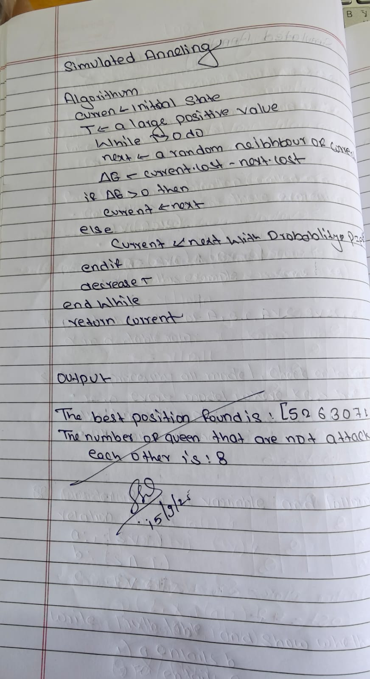

import numpy as np

print("soham Hathi")

print("1BM23CS335")

def compute_conflicts(queens):

"""Compute number of pairs of queens attacking each other."""

conflicts = 0

n = len(queens)

for i in range(n):

for j in range(i + 1, n):

if queens[i] == queens[j] or abs(queens[i] - queens[j]) == abs(i - j):

conflicts += 1

return conflicts

def random_neighbor(queens):

"""Generate a neighbor by swapping two random positions."""

n = len(queens)

new_queens = queens.copy()

i, j = np.random.choice(n, 2, replace=False)

new_queens[i], new_queens[j] = new_queens[j], new_queens[i]

return new_queens

def simulated_annealing(n, initial_temp=100, cooling_rate=0.95, max_iter=10000):

queens = np.arange(n) # Start with a permutation (0 to n-1)

current_conflicts = compute_conflicts(queens)

best_queens = queens.copy()

best_conflicts = current_conflicts

temp = initial_temp

for i in range(max_iter):

if temp <= 1e-3 or best_conflicts == 0:

break

candidate = random_neighbor(queens)

candidate_conflicts = compute_conflicts(candidate)

delta = candidate_conflicts - current_conflicts

if delta < 0 or np.random.rand() < np.exp(-delta / temp):

queens = candidate

current_conflicts = candidate_conflicts

if current_conflicts < best_conflicts:

best_queens = queens.copy()

best_conflicts = current_conflicts

temp *= cooling_rate

return best_queens, n - best_conflicts

n = 8

solution, non_attacking_queens = simulated_annealing(n)

print(f"The best position found is: {solution}")

print(f"The number of queens that are not attacking each other is: {non_attacking_queens}")

**PROGRAM-6**

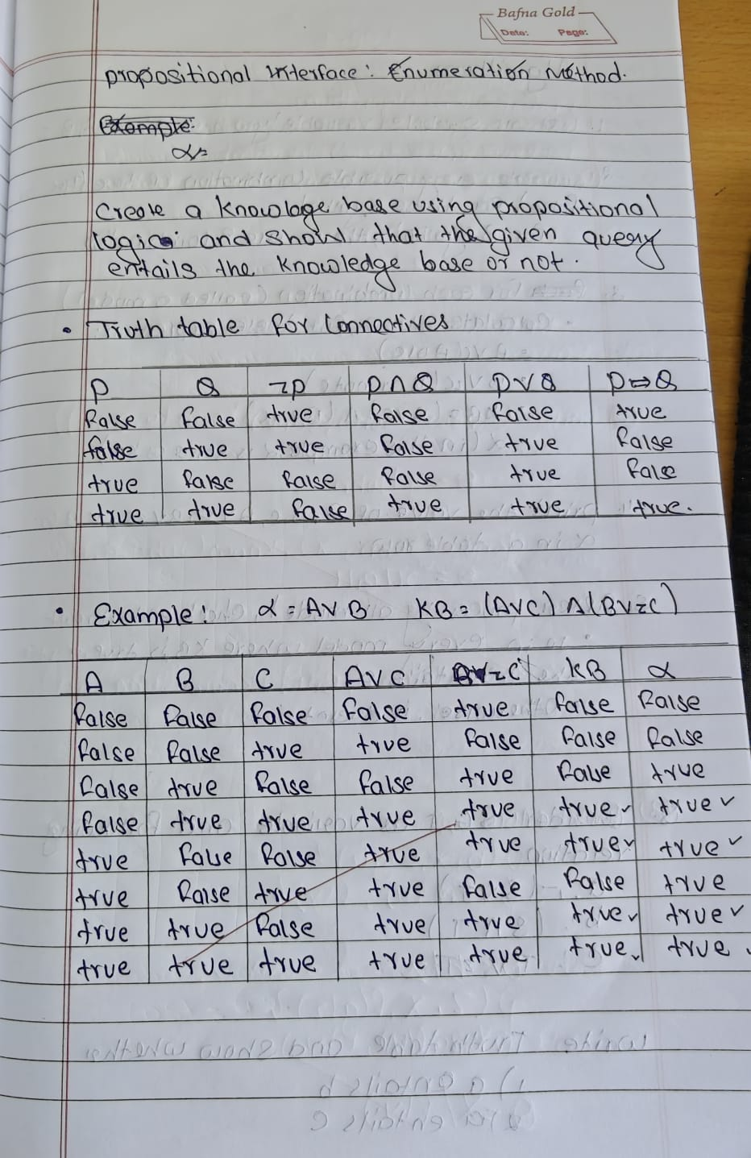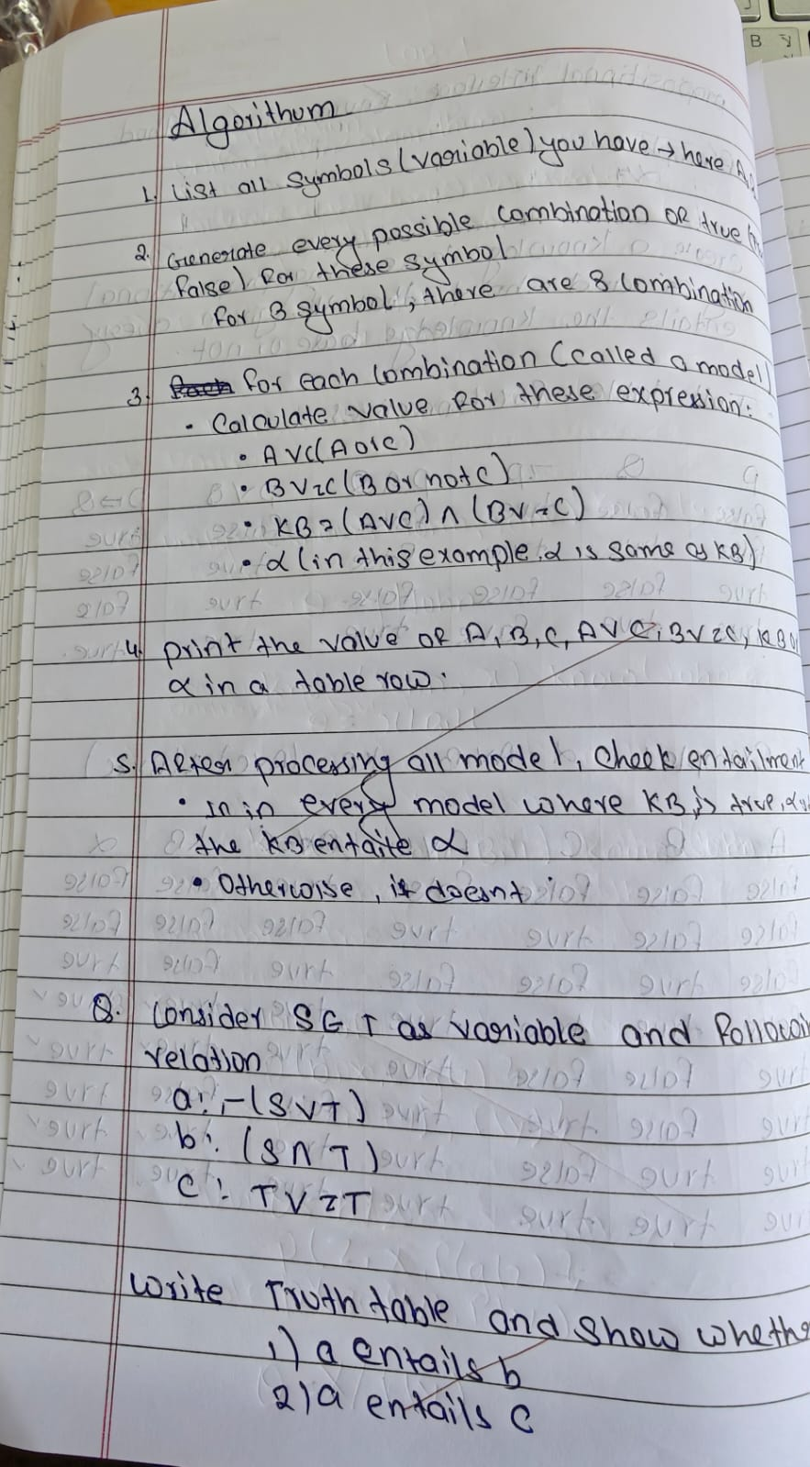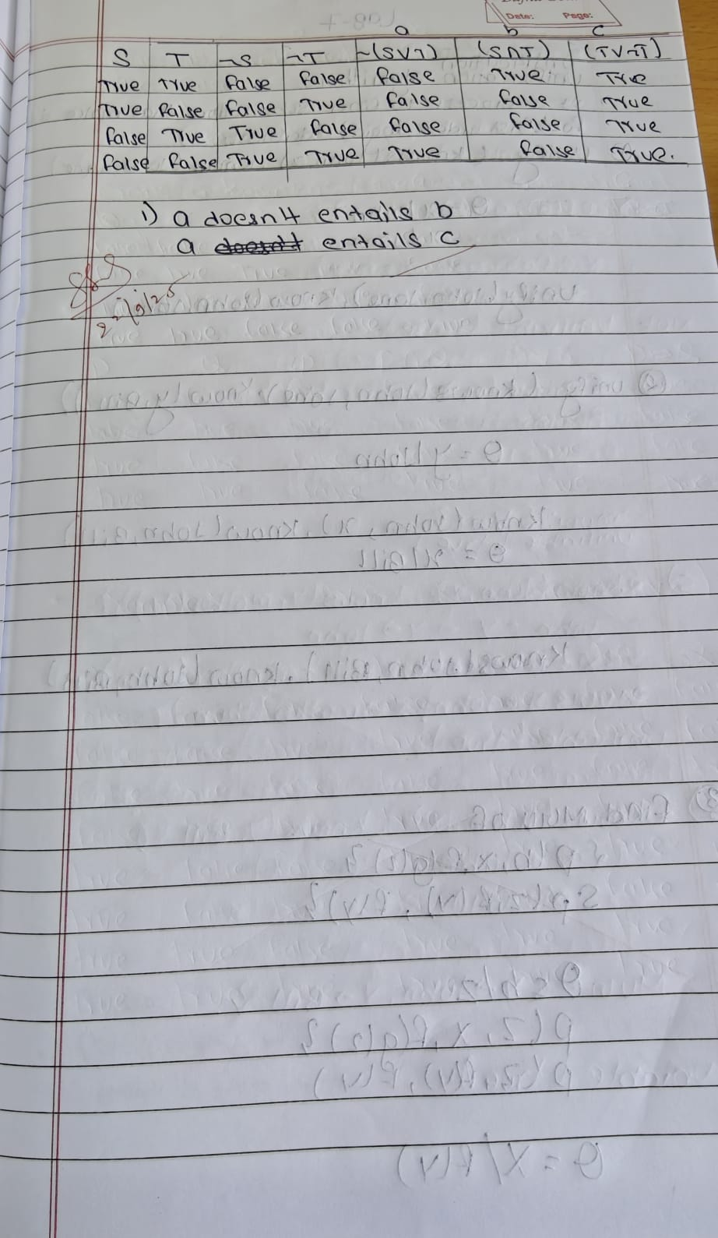

print("Soham Hathi 1BM23CS335")

from itertools import product

def pl_true(sentence, model):

if sentence == "A":

return model["A"]

elif sentence == "B":

return model["B"]

elif sentence == "C":

return model["C"]

elif sentence == "A_or_C":

return model["A"] or model["C"]

elif sentence == "B_or_not_C":

return model["B"] or (not model["C"])

elif sentence == "KB":

return (model["A"] or model["C"]) and (model["B"] or (not model["C"]))

elif sentence == "alpha":

return model["alpha"]

else:

return False

def print_truth_table():

print(f"{'A':<7} {'B':<7} {'C':<7} {'A∨C':<7} {'B∨¬C':<7} {'KB':<7} {'α':<7}")

print("-"*50)

all_rows = []

for values in product([False, True], repeat=3):

model = {"A": values[0], "B": values[1], "C": values[2]}

model["A_or_C"] = pl_true("A_or_C", model)

model["B_or_not_C"] = pl_true("B_or_not_C", model)

model["KB"] = pl_true("KB", model)

model["alpha"] = model["KB"]

all_rows.append(model)

print(f"{str(model['A']).lower():<7} {str(model['B']).lower():<7} {str(model['C']).lower():<7} "

f"{str(model['A_or_C']).lower():<7} {str(model['B_or_not_C']).lower():<7} "

f"{str(model['KB']).lower():<7} {str(model['alpha']).lower():<7}")

return all_rows

def tt_entails(all_rows):

for model in all_rows:

if model["KB"] and not model["alpha"]:

return False

return True

def main():

all_rows = print_truth_table()

entails = tt_entails(all_rows)

print("\nDoes KB entail α? ", entails)

if __name__ == "__main__":

**PROGRAM-7**

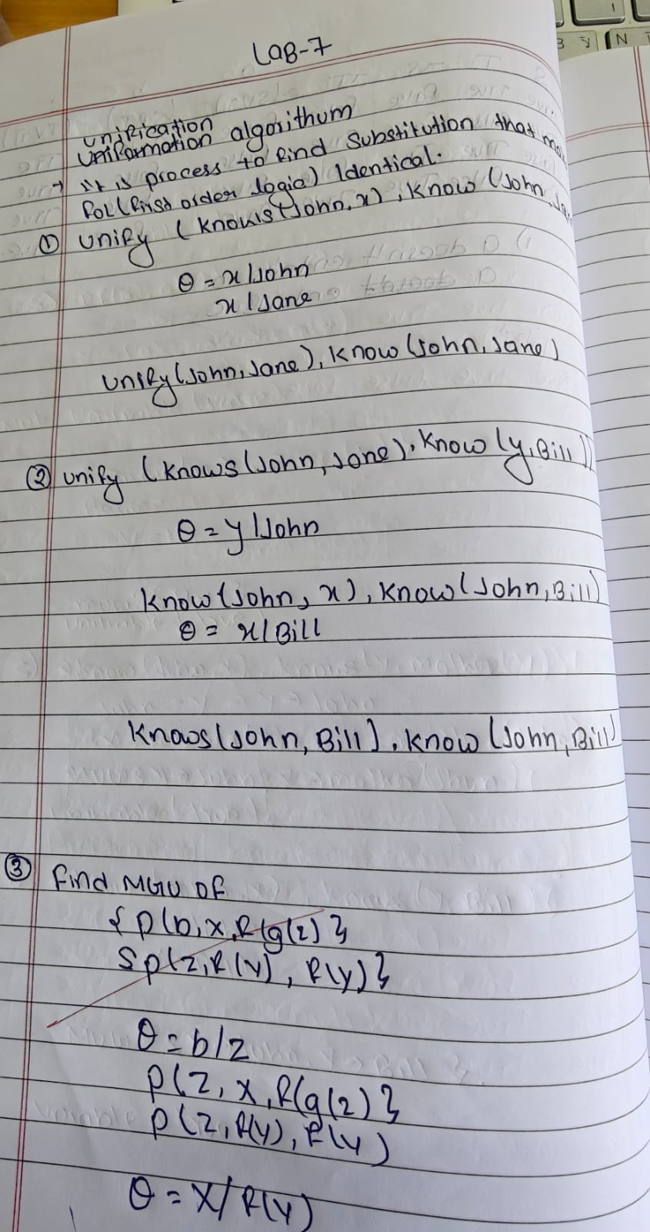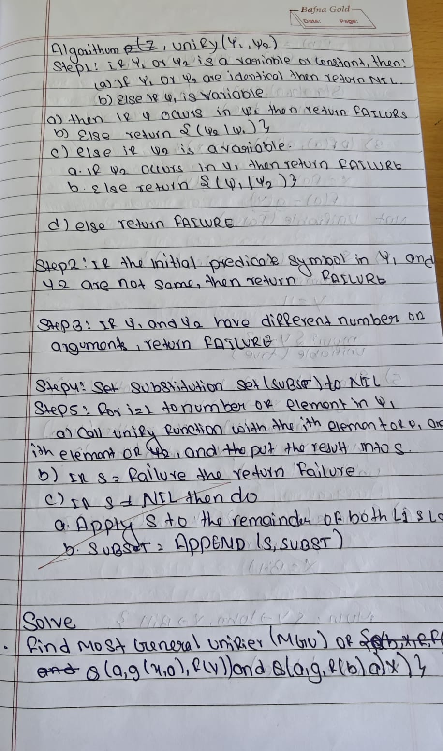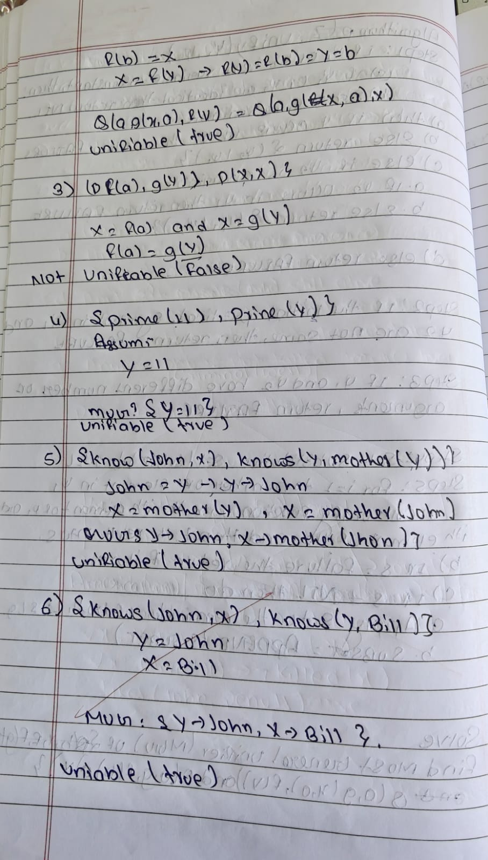

# Unification algorithm (fixed parser & example)

import re

def is_variable(x):

"""Variable if it is a string and starts with an uppercase letter."""

return isinstance(x, str) and len(x) > 0 and x[0].isupper()

def unify(x, y, subs=None):

if subs is None:

subs = {}

if x == y:

return subs

if is_variable(x):

return unify_var(x, y, subs)

if is_variable(y):

return unify_var(y, x, subs)

if isinstance(x, tuple) and isinstance(y, tuple):

if x[0] != y[0] or len(x[1]) != len(y[1]):

return None

for a, b in zip(x[1], y[1]):

subs = unify(apply_subs(a, subs), apply_subs(b, subs), subs)

if subs is None:

return None

return subs

return None

def unify_var(var, x, subs):

if var in subs:

return unify(subs[var], x, subs)

elif is_variable(x) and x in subs:

return unify(var, subs[x], subs)

elif occur_check(var, x, subs):

return None

else:

subs[var] = x

return subs

def occur_check(var, x, subs):

if var == x:

return True

elif isinstance(x, tuple):

return any(occur_check(var, arg, subs) for arg in x[1])

elif isinstance(x, str) and is_variable(x) and x in subs:

return occur_check(var, subs[x], subs)

return False

def apply_subs(term, subs):

if isinstance(term, str) and is_variable(term) and term in subs:

return apply_subs(subs[term], subs)

elif isinstance(term, tuple):

return (term[0], [apply_subs(t, subs) for t in term[1]])

return term

def parse_term(expr):

expr = expr.strip()

# strip outer braces if present, e.g. "{ ... }"

if expr.startswith('{') and expr.endswith('}'):

expr = expr[1:-1].strip()

if '(' not in expr:

return expr

functor = expr[:expr.index('(')].strip()

args = expr[expr.index('(')+1:-1]

return (functor, parse_args(args))

def parse_args(s):

args, level, current = [], 0, ''

for ch in s:

if ch == ',' and level == 0:

args.append(parse_term(current.strip()))

current = ''

else:

if ch == '(':

level += 1

elif ch == ')':

level -= 1

current += ch

if current.strip():

args.append(parse_term(current.strip()))

return args

expr1 = "prime(11)"

expr2 = "prime(Y)" # NOTE: Y is uppercase -> variable

term1 = parse_term(expr1)

term2 = parse_term(expr2)

result = unify(term1, term2)

if result:

print("MGU:", result)

else:

print("No unifier found.")

**PROGRAM 8**

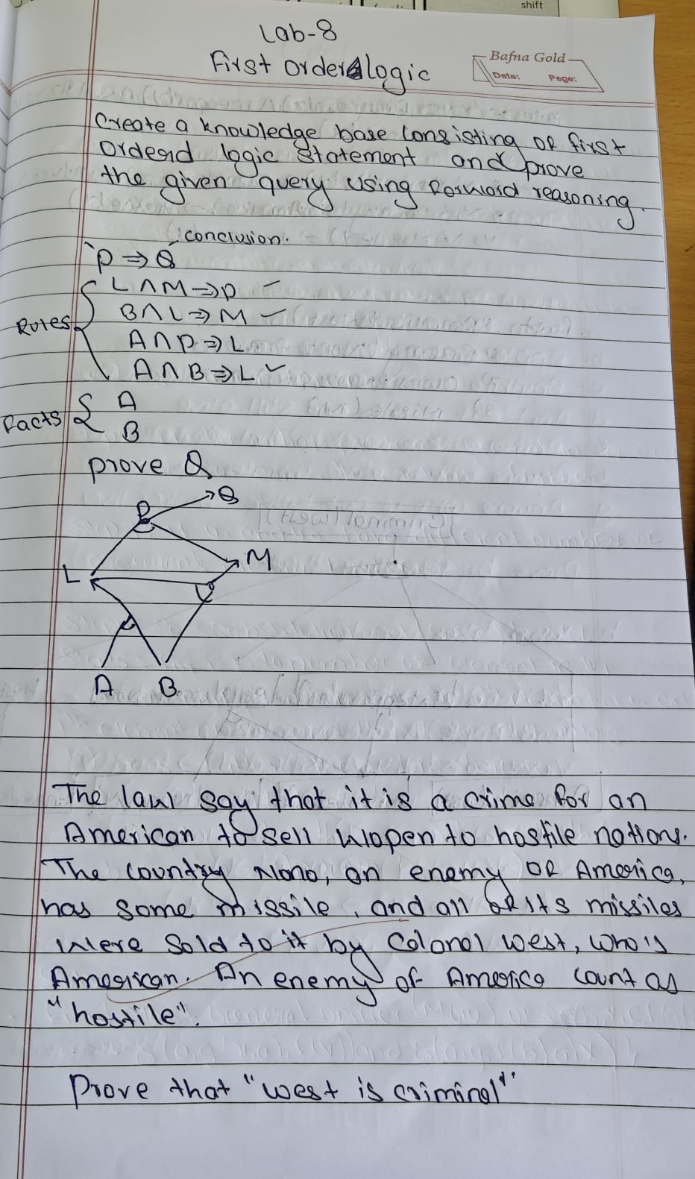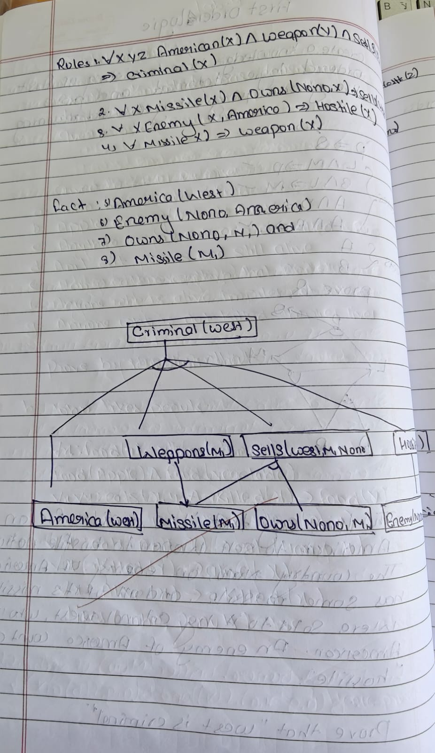

import copy

from itertools import product

print("Soham Hathi")

print("1BM23CS335")

def is_variable(x):

return isinstance(x, str) and x[0].islower()

def substitute(expr, subs):

if isinstance(expr, list):

return [substitute(e, subs) for e in expr]

else:

return subs.get(expr, expr)

def unify(x, y, subs=None):

if subs is None:

subs = {}

if subs is False:

return False

elif x == y:

return subs

elif is_variable(x):

return unify_var(x, y, subs)

elif is_variable(y):

return unify_var(y, x, subs)

elif isinstance(x, list) and isinstance(y, list):

if len(x) != len(y):

return False

for xi, yi in zip(x, y):

subs = unify(xi, yi, subs)

if subs is False:

return False

return subs

else:

return False

def unify_var(var, x, subs):

if var in subs:

return unify(subs[var], x, subs)

elif x in subs:

return unify(var, subs[x], subs)

else:

subs[var] = x

return subs

def forward_chain(KB, query):

facts = [list(f) for f in KB['facts']]

added = True

while added:

added = False

for premises, conclusion in KB['rules']:

all_matches = []

for premise in premises:

matches = []

for fact in facts:

subs = unify(premise, fact)

if subs:

matches.append(subs)

all_matches.append(matches)

for combo in product(*all_matches):

merged = {}

for subs in combo:

merged.update(subs)

inferred = substitute(conclusion, merged)

if inferred not in facts:

facts.append(inferred)

added = True

if inferred == query:

return True

return query in facts

KB = {

'facts': [

["American", "West"],

["Weapon", "Missile"],

["Sells", "West", "Missile", "Nono"],

["Enemy", "Nono", "America"]

],

'rules': [

# Rule 1: Enemy of America → Hostile

([[ "Enemy", "x", "America" ]], [ "Hostile", "x" ]),

# Rule 2: American sells weapon to hostile nation → Criminal

([[ "American", "x" ], [ "Weapon", "y" ], [ "Sells", "x", "y", "z" ], [ "Hostile", "z" ]],

[ "Criminal", "x" ])

]

}

query = ["Criminal", "West"]

result = forward_chain(copy.deepcopy(KB), query)

print("\nQuery:", query)

print("Result:", " TRUE" if result else "FALSE")

**PROGRAM-9**

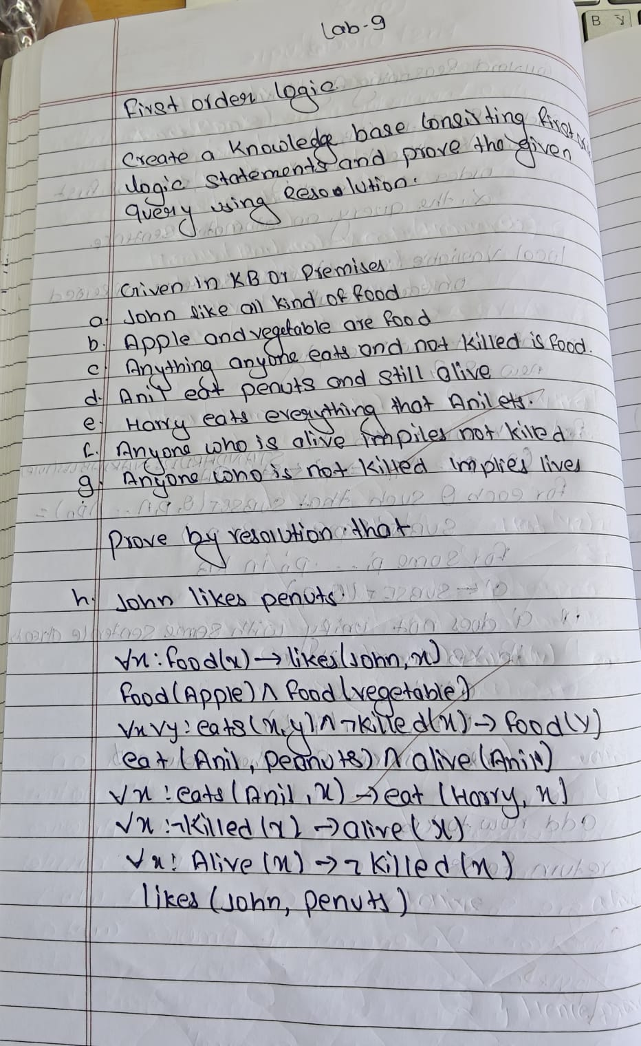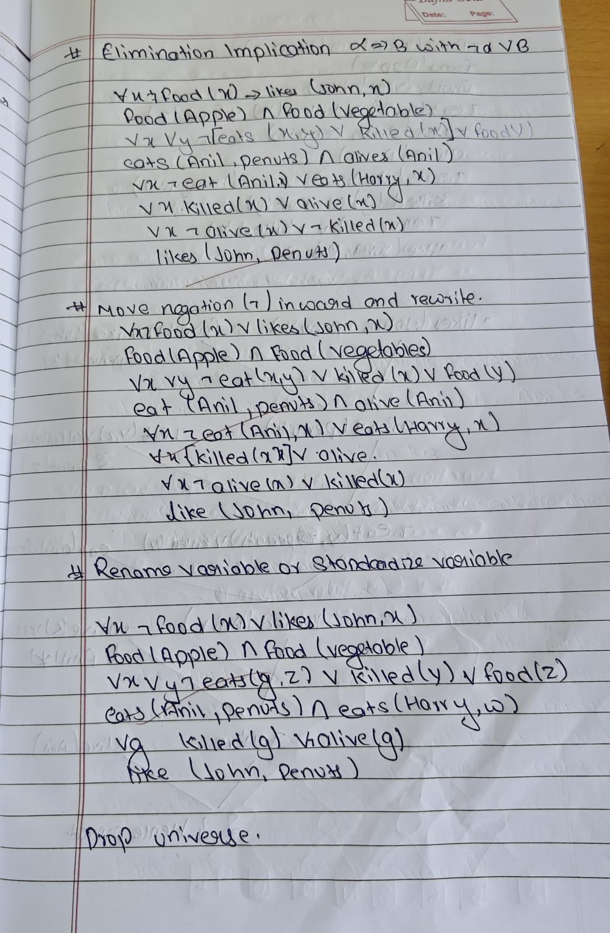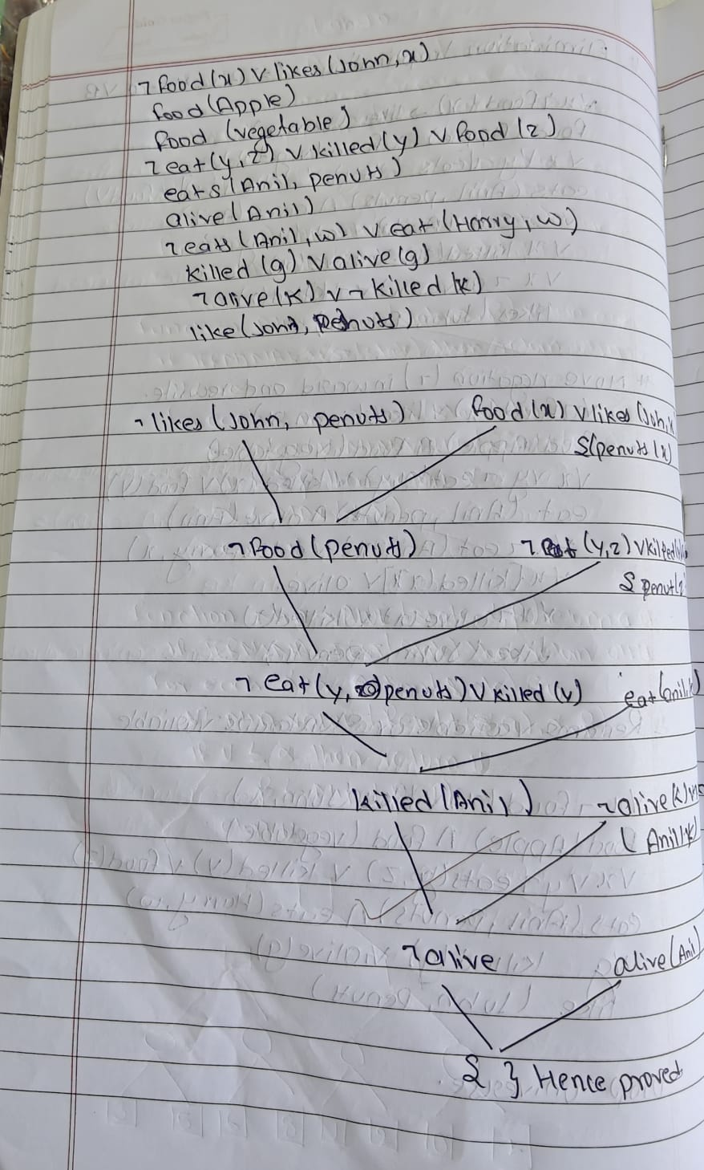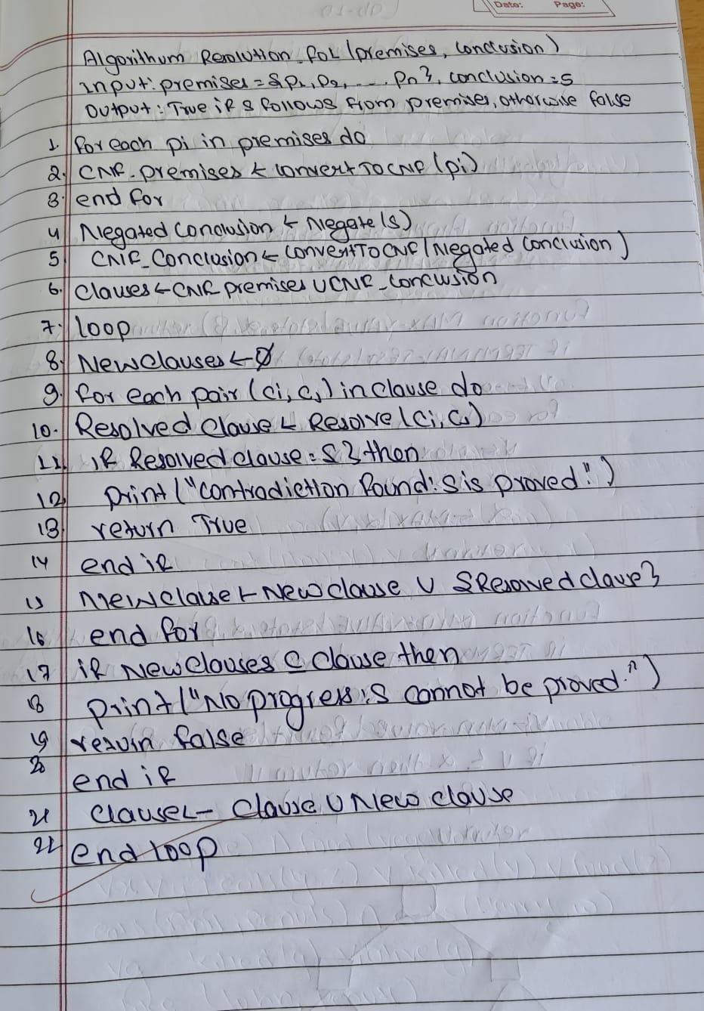

print("Soham Hathi")

print("1BM23CS335")

from typing import List, Set

def substitute(clause, var, value):

"""Substitute a variable with a value in a clause."""

return {literal.replace(var, value) for literal in clause}

def unify(literal1: str, literal2: str):

"""Check if two literals can be unified and return substitution if possible."""

if literal1.startswith("~"):

l1_pred = literal1[1:]

neg1 = True

else:

l1_pred = literal1

neg1 = False

if literal2.startswith("~"):

l2_pred = literal2[1:]

neg2 = True

else:

l2_pred = literal2

neg2 = False

# Must have same predicate name

if l1_pred.split("(")[0] != l2_pred.split("(")[0]:

return None

# Must be opposite signs for resolution

if neg1 == neg2:

return None

args1 = l1_pred[l1_pred.find("(")+1:-1].split(",")

args2 = l2_pred[l2_pred.find("(")+1:-1].split(",")

if len(args1) != len(args2):

return None

substitution = {}

for a1, a2 in zip(args1, args2):

a1, a2 = a1.strip(), a2.strip()

# Variable (lowercase) can unify with constant (uppercase)

if a1[0].islower() and not a2[0].islower():

substitution[a1] = a2

elif a2[0].islower() and not a1[0].islower():

substitution[a2] = a1

elif a1 != a2:

return None

return substitution

def resolve(clause1: Set[str], clause2: Set[str]):

"""Resolve two clauses."""

resolvents = []

for lit1 in clause1:

for lit2 in clause2:

substitution = unify(lit1, lit2)

if substitution:

(var, val) = list(substitution.items())[0]

new_clause1 = substitute(clause1 - {lit1}, var, val)

new_clause2 = substitute(clause2 - {lit2}, var, val)

new_clause = new_clause1.union(new_clause2)

resolvents.append((lit1, lit2, substitution, new_clause))

return resolvents

def resolution(kb: List[Set[str]], query: Set[str]) -> bool:

"""Resolution algorithm with step-by-step printing."""

clauses = kb + [set(f"~{q}" for q in query)] # Negate query

step = 1

print("\n--- Resolution Steps ---")

while True:

n = len(clauses)

pairs = [(clauses[i], clauses[j]) for i in range(n) for j in range(i + 1, n)]

new = set()

for (ci, cj) in pairs:

resolvents = resolve(ci, cj)

for (lit1, lit2, substitution, result_clause) in resolvents:

print(f"\nStep {step}:")

print(f"Resolving {ci} and {cj}")

print(f" - Unifying {lit1} with {lit2}")

print(f" - Substitution: {substitution}")

print(f" - Resulting clause: {result_clause if result_clause else '{}'}")

step += 1

if not result_clause: # Empty clause => proved

print("\n❗ Contradiction found — query is proven true.")

return True

new.add(frozenset(result_clause))

if new.issubset(set(map(frozenset, clauses))):

print("\nNo new clauses — query cannot be proven.")

return False

for c in new:

if c not in clauses:

clauses.append(set(c))

def main():

print("=== First Order Logic Resolution Prover ===")

n = int(input("Enter number of clauses in the knowledge base: "))

kb = []

print("\nEnter each clause separated by OR (|). Use '~' for NOT.\n")

for i in range(n):

clause_str = input(f"Clause {i+1}: ").replace(" ", "")

literals = set(clause_str.split("|"))

kb.append(literals)

query_str = input("\nEnter query: ").replace(" ", "")

query = {query_str}

print("\n=== Resolution Process ===")

result = resolution(kb, query)

print("\n Final Result:", "Proved " if result else "Not Proved ")

if __name__ == "__main__":

**PROGRAM-10**

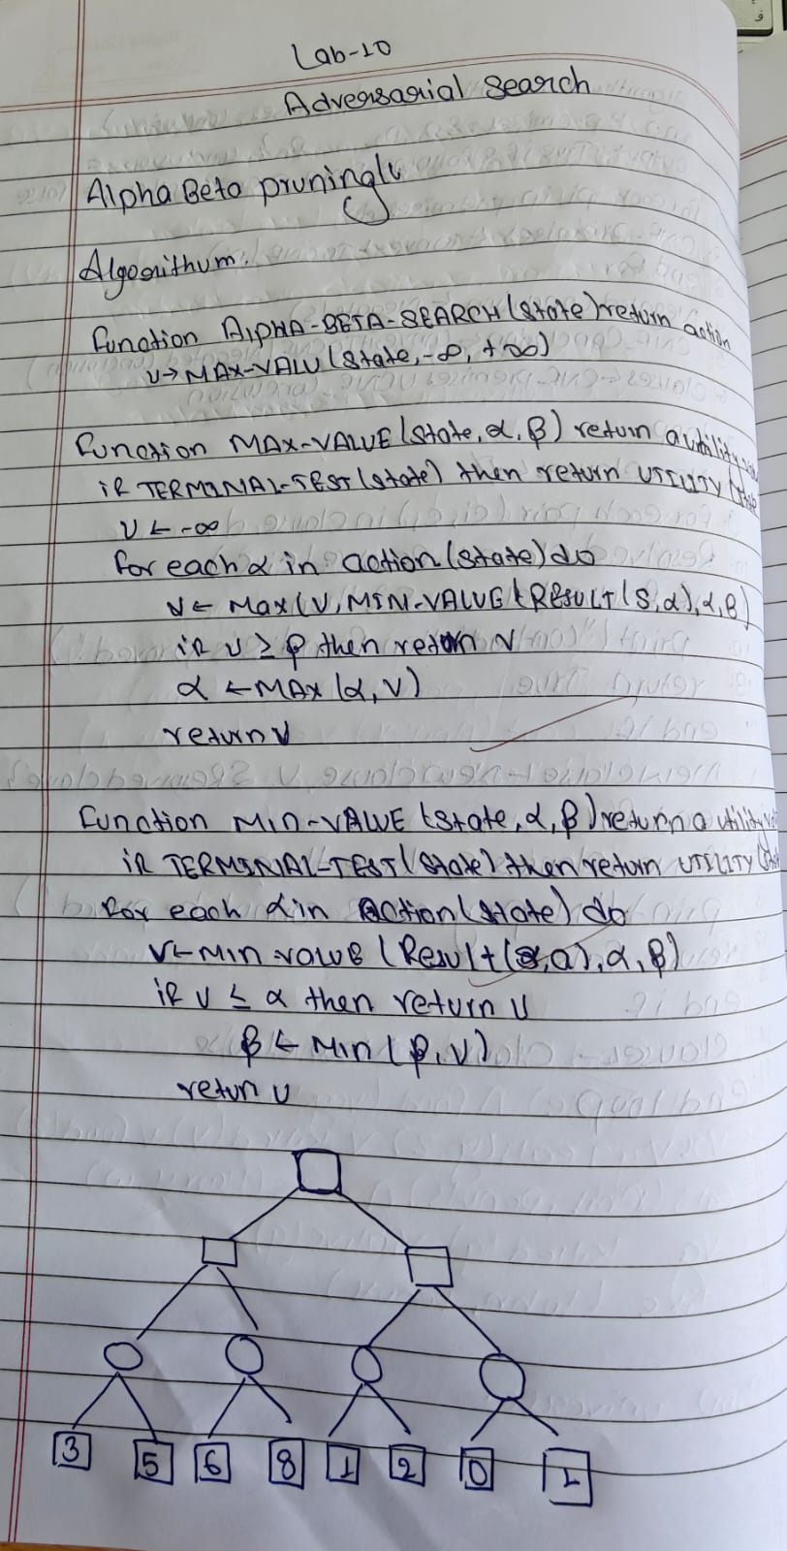

)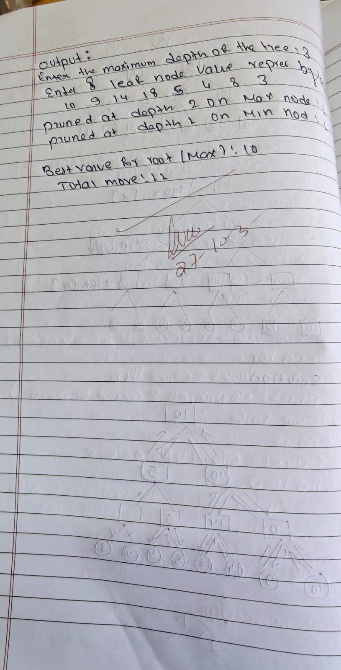

print("Soham Hathi")

print("1BM23CS335")

import math

# --- Alpha-Beta Search ---

def alpha_beta_search(values, max_depth):

"""Alpha-Beta Search using standard pseudocode."""

tree = {} # to store computed node values

pruned = [] # to store pruned branches

def max_value(depth, node_index, alpha, beta):

indent = " " * depth

if depth == max_depth:

print(f"{indent}Leaf Node[{node_index}] = {values[node_index]}")

tree[(depth, node_index)] = values[node_index]

return values[node_index]

print(f"{indent}MAX Node[{node_index}] (α={alpha}, β={beta})")

v = -math.inf

for i in range(2):

child_index = node_index * 2 + i

val = min_value(depth + 1, child_index, alpha, beta)

v = max(v, val)

alpha = max(alpha, v)

print(f"{indent}→ MAX[{node_index}] updated to {v} (α={alpha}, β={beta})")

if v >= beta:

print(f"{indent}⛔ Beta cutoff at Node[{child_index}]")

pruned.append((depth, node_index, "β"))

break

tree[(depth, node_index)] = v

return v

def min_value(depth, node_index, alpha, beta):

indent = " " * depth

if depth == max_depth:

print(f"{indent}Leaf Node[{node_index}] = {values[node_index]}")

tree[(depth, node_index)] = values[node_index]

return values[node_index]

print(f"{indent}MIN Node[{node_index}] (α={alpha}, β={beta})")

v = math.inf

for i in range(2):

child_index = node_index * 2 + i

val = max_value(depth + 1, child_index, alpha, beta)

v = min(v, val)

beta = min(beta, v)

print(f"{indent}→ MIN[{node_index}] updated to {v} (α={alpha}, β={beta})")

if v <= alpha:

print(f"{indent}⛔ Alpha cutoff at Node[{child_index}]")

pruned.append((depth, node_index, "α"))

break

tree[(depth, node_index)] = v

return v

print("\n=== Alpha–Beta Search Steps ===")

best_value = max_value(0, 0, -math.inf, math.inf)

return best_value, tree, pruned

# --- Function to Print Tree in ASCII ---

def print_tree(values, tree, max_depth):

print("\n=== TREE STRUCTURE ===")

index = 0

for depth in range(max_depth + 1):

nodes = 2 ** depth

line = ""

for i in range(nodes):

if (depth, i) in tree:

val = tree[(depth, i)]

else:

val = "—"

line += f"[{val:^5}] "

print(" " * (max_depth - depth) + line)

print()

# --- Main Program ---

def main():

print("=== Alpha–Beta Search Algorithm (Text Tree Output) ===")

max_depth = int(input("Enter maximum depth of tree (e.g., 3): "))

num_leaves = 2 ** max_depth

print(f"\nEnter {num_leaves} leaf node values (space-separated):")

values = list(map(int, input().split()))

if len(values) != num_leaves:

print(f"Error: Expected {num_leaves} values for a complete binary tree.")

return

best_value, tree, pruned = alpha_beta_search(values, max_depth)

print_tree(values, tree, max_depth)

print("=== RESULTS ===")

print(f"Optimal root node value: {best_value}")

if pruned:

print("Pruned branches:")

for p in pruned:

print(f" Node[{p[1]}] at depth {p[0]} ({p[2]} cutoff)")

else:

print("No pruning occurred.")

if __name__ == "__main__":

main()